Setup visual studio community, its free to use maybe they want a mail address.
https://visualstudio.microsoft.com/de/downloads/

Then after the install it comes and asks for if you want to install any plugins.
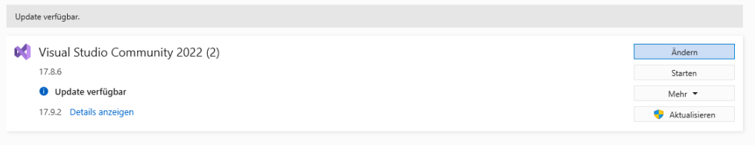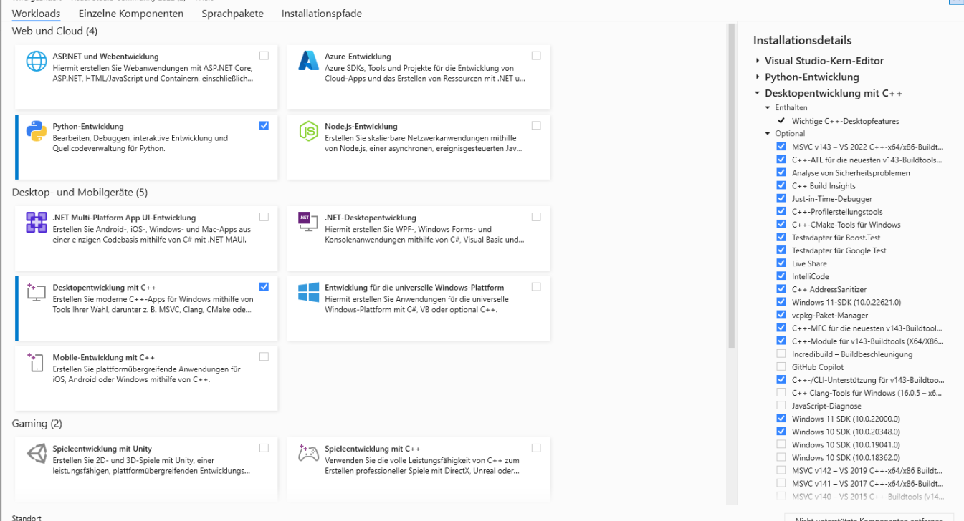

You need to have those packages installed within of visual studio that’s all, you’re done with visual studio here. Python is not needed its only there for me for some debugging.
Then you need to have the nvidia cuda SDK which you get here
https://developer.nvidia.com/cuda-downloads

the cuda has to be installed after visual studio, otherwise it will never work.

Last step is to pip install llama-cpp-python
You have to set the two environment variables and then use the pip install line from below

$Env:CMAKE_ARGS="-DLLAMA_CUBLAS=on"
$Env:FORCE_CMAKE="1"
pip install llama-cpp-python --force-reinstall --upgrade --no-cache-dir

Bonus, if you want torch to run on GPU just do this, it will work without any of the above steps
pip3 install torch torchvision torchaudio --index-url https://download.pytorch.org/whl/cu121

I just learned that sometimes this one does not work and a user gave me this:

I think I figured out what the problem is. It seems that for some people, setting CMAKE_ARGS doesn't work. So I took the advice from here abetlen/llama-cpp-python#284 (comment).
So first, clone the llama-cpp-python repository with the --recurse-submodules option. Then in vendor/llama.cpp, edit CMakeLists.txt and change LLAMA_CUBLAS to ON.
Then create a venv in the llama-cpp-python directory and run set FORCE_CMAKE = 1 && pip install . -vv. This will take a while to finish. Once that's done, copy the llama_cpp and llama_cpp_python-0.2.57.dist-info directories inside venv/Lib/site-packages and paste them into installer_files\env\Lib\site-packages.
Only after doing it that way was I able to get it to use the GPU.

